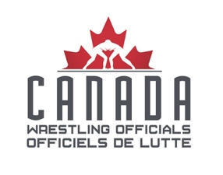
CAWO APPLICATION FOR CATEGORY AE

This application is to be filled out and submitted to the VP National no later than December 31st of the season that you wish to be considered for promotion. Applicants must ensure that they have read and understand the CAWO Policies and Procedures Manual (P&P) especially as it pertains to the Category “CAN AE”. If you have any questions or concerns regarding this form or the application process, please contact the VP National.

Applicant Name?

Which provincial association are you a member of?

How many years have you been a member of CAWO? Of those years how long have you been a “CAN A”?

Are you a CAWO member in good standing?

Please list the tournaments and corresponding dates of which you have worked in the capacity of head official or clinician. You may also list the times when you have apprenticed under another official in those capacities.

EVENT | DATE | YOUR ROLE

Any additional notes regarding events listed above

Will you be attending the U17/U19 Canadian Championships this season?

Please provide a brief explanation of what becoming a “CAN AE” means to you. Why do you feel that you are ready and why should you be considered for this role?

Are there any additional details you would like us to know about?

PLEASE SEND COMPLETED FORMS TO THE CAWO VP NATIONAL

